7th Grade LIBERTY PINES ACADEMY SUPPLY LIST 2019-2020
7th Grade HOMEROOM SUPPLIES  These items will be collected by homeroom teacher. | 7th Grade GENERAL SUPPLIES needed for the entire year. | LANGUAGE ARTS 2  (Standard & Advanced)
All Students:  2-Tissue Boxes  1-Post-it Notes  1-Notebooks/ Index Cards  1-Package of Expo Markers  1-Ream of Copy Paper  2-Scotch tape/Glue sticks  1-Clorox Wipes  1- 8 oz. pump of hand sanitizer  30- Count #2 Pencils | Every student needs to carry a pencil pouch daily to all classes with:  1-Colored Pencils (sharpened)  1-Package of highlighters  2- Post-its  2-Different colored pens (any color)  2-Mechanical Pencils/Lead or Sharpened Pencils (personal hand-held sharpener)  4-Glue Sticks or Scotch Tape  1-Scissors | 1-1” BLUE binder  5-Dividers (write on tabs)  1-Composition notebook  2-Wide-ruled loose leaf paper
MATH 2  (Standard & Advanced) | ALGEBRA 1 Honors | SCIENCE 2  (Standard & Advanced)
2- RED 1 ½” Heavy Duty Binder  3- Packages of notebook paper  1 – Package of 5 tab dividers  1- Graph paper (advanced)  1 - Texas Instrument- TI-30Xa  1- Package of College Ruled Paper  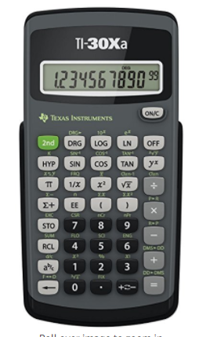 | 1 – Red 1” Binder  1- Package of 5 tab dividers  1 – 5 Subject college ruled spiral notebook  1 – package of graph paper  1 - package of mechanical pencils  1 -Texas Instrument –TI30Xa | 1-GREEN binder  2-packs notebook paper  5-Dividers w/tabs  1-pack of Notecards  1 Package of 3”x3” Sticky Notes
CIVICS  (Standard & Advanced) | Electives | Electives
3-Composition books  1-2 inch BLACK binder  5-Dividers w/tabs  3-packs notebook paper  1-hole reinforcements | Physical Education-  Uniform ($25.00/set)  Composition book  Spanish-  - ½’ Binder (clear front)  1-notebook paper  4-dividers  Ear buds  Band-  1-Subject Spiral notebook | Drama -  1-Composition book  1-70 page spiral notebook  1-2 pocket folder  Art-  1- 8.5 X 5.5 Sketchbook  4-sharpies  ICT –  1- College Ruled Composition book  1- 70 page spiral notebook college ruled

