HEALTH SERVICES | CLINIC NEWS

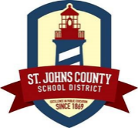 Liberty Pines Academy

As we near the end of the school year, I would like to remind you that your child’s medication must be picked up from the clinic by Thursday June 2,2022. School policy does not allow for medication to remain in the school over the summer. It will be important for you to make arrangements to pick up your child’s medication since medications may not go home with the student. Any medication left in the clinic after 6/2/22 will be discarded according to policy.

On our website you will find medication forms for next year. As you know, medication orders must be completed every school year whether your child remains in the same school or goes to another. If your child has a physical examination during the summer months, this is a good time to get the medication forms completed.

For your convenience, the clinic will be open during your student’s meet the teacher time at LPA to accept your child’s medication and completed medication forms.

If you have any questions during the summer, please contact the school clinic at LPAclinic@stjohns.k12.fl.us.

Have a safe and healthy summer!

Damaris Mayernik LPN

Rachel Walker RN

