Liberty Pines Academy Café
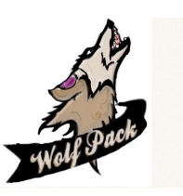
Price list
All snacks we offer meet the healthy snack guidelines

Elementary lunch: $2.80

Secondary lunch: $2.95

Reduced lunch: .40

Breakfast: $1.25

Reduced breakfast: .30

Adult lunch: $3.75

Adult breakfast: $ 1.60

Baked chip variety: $1.00 String cheese: .50
Yogurt: .75 Reduced sugar fruit snack: .75
Whole grain cocoa cherry bar: .75 Milk: .60
8oz water: .75

Middle School
20oz water: $1.50 12oz water: $1.25
Izze:
$1.25 10oz Juice: $1.50

