8th Grade LIBERTY PINES ACADEMY SUPPLY LIST 2019-2020
8th Grade HOMEROOM SUPPLIES  These items will be collected by homeroom teacher. | 8th Grade GENERAL SUPPLIES needed for the entire year. | LANGUAGE ARTS  (Standard & Advanced)
All Students:  2-Tissue Boxes  1-Pack of 3x3” Post-it Notes  1-Pack of 3x5” Index Cards  1-Package of Expo Markers with cleaner pack preferred  1-Ream of Copy Paper  3-Scotch tape or Glue sticks  1-Clorox Wipes  1- 8 oz. pump of hand sanitizer | Every student needs to carry a pencil pouch daily to all classes with:  Pencils  Pens (blue/black)  Colored Pencils  Thin tipped colored marker  Multi-colored highlighters  2- Post-its  For binders:  10- College ruled notebook paper | 1-1” BLUE binder  5-Dividers (write on tabs)  2-Composition notebook  1 – 32 GB Flash Drive
Pre-Algebra | ALGEBRA 1 Honors | Geometry Honors
2- RED 1 ½” Heavy Duty Binder  1-Package Graph paper  2-Packages of dividers (5)  1 - Texas Instrument- TI-30Xa  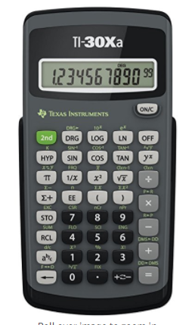 | 1 – Red 1” Binder  1- Package of 5 dividers  1 – 5 Subject college ruled spiral notebook  1 – package of graph paper  1 - package of mechanical pencils  1 -Texas Instrument –TI30Xa | 1-Red binder  1-Package of graph paper  2-Packages of dividers (5)  1-Protractor  1-Compass  1 - Texas Instrument –TI30Xa
Comprehensive Science 3  (Standard & Advanced) | Physical Science Honors | U.S History  (Standard & Advanced)
2- 5 Subject Notebooks (5 Star-Pockets in each divider)  Colored writing pens  Highly recomened-not required  Book: Everything You Need to Ace Science in One Big Fat Notebook. | 2” Binder-Green  1 Package of dividers (5)  1 Package of college ruled paper | 1” Binder-Black  1 Package of dividers (5)  1 – package of colored pencils  1 – package of college ruled paper
Advanced Drama | Theater Production and Design | Art
1-Composition book  1-70 page spiral notebook  1-2 pocket folder with prongs | 1-Composition book  1-70 page spiral notebook  1-9”x12” sketchbook  1- pair of safety goggles | 1- 8.5 X 5.5 Sketchbook
Physical Education | Spanish | Band
Uniform ($25.00/set)  Composition book | - ½’ Binder (clear front)  4-dividers  Ear buds | 1-Single subject Spiral notebook
Journalism | ICT | Emerging Technologies
1- Stenographers notebook  1- pocket folder with prongs | 1-Composition book  1-70 page spiral notebook | 1-Composition book  1-70 page spiral notebook

