Georgia O’Keeffe (O-keef) American 1887-1986
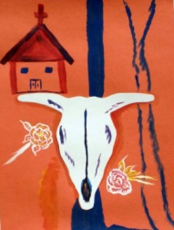
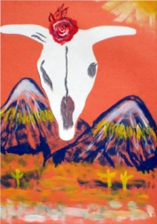
The children were introduced to O’Keeffe’s style of bold colors and shapes, along with desert scenes of New Mexico.
ART ACTIVITY EMPHASIS: Painting desert scenes and flowers.
Media: Cut paper and paint

Name: Teacher: Date:
Georgia O’Keeffe (O-keef) American 1887-1986
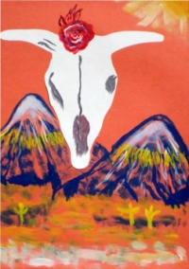
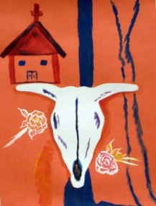
The children were introduced to O’Keeffe’s style of bold colors and shapes, along with desert scenes of New Mexico.
ART ACTIVITY EMPHASIS: Painting desert scenes and flowers.
Media: Cut paper and paint

Name: Teacher: Date:

Georgia O’Keeffe (O-keef) American 1887-1986
The children were introduced to O’Keeffe’s style of bold colors and shapes, along with desert scenes of New Mexico.
ART ACTIVITY EMPHASIS: Painting desert scenes and flowers.
Media: Cut paper and paint

Name: Teacher: Date:

